CONFIDENTIAL
Name of applicant: | Click or tap here to enter text.
Address: | Click or tap here to enter text.
Trust / School: | Click or tap here to enter text.
Present post: | Click or tap here to enter text.

Dear Father
The above-named person has applied to be a Foundation Director and has nominated you as a referee who can confirm that they are a practising Catholic. As representatives of the Diocesan Bishop, Foundation Directors must be practising Catholics, who are seen to support the Church’s teachings; they must understand the Catholic character of the school and the needs of the Catholic community as a whole, as reflected in the education and pastoral policies of the diocese.
Please confirm that to the best of your knowledge and belief:
- the applicant complies with the obligation to participate in the Mass on Sundays and Holydays of Obligation
- the applicant has received the Sacrament of Confirmation
- there is no moral or canonical impediment which precludes the applicant from receiving the Sacrament of the Eucharist regularly, and that he or she does receive it at least once a year
- the applicant provides for the needs of the Church.
Thank you for your help.
Yours sincerely

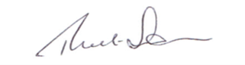

Robert Simpson
Director of Education

